

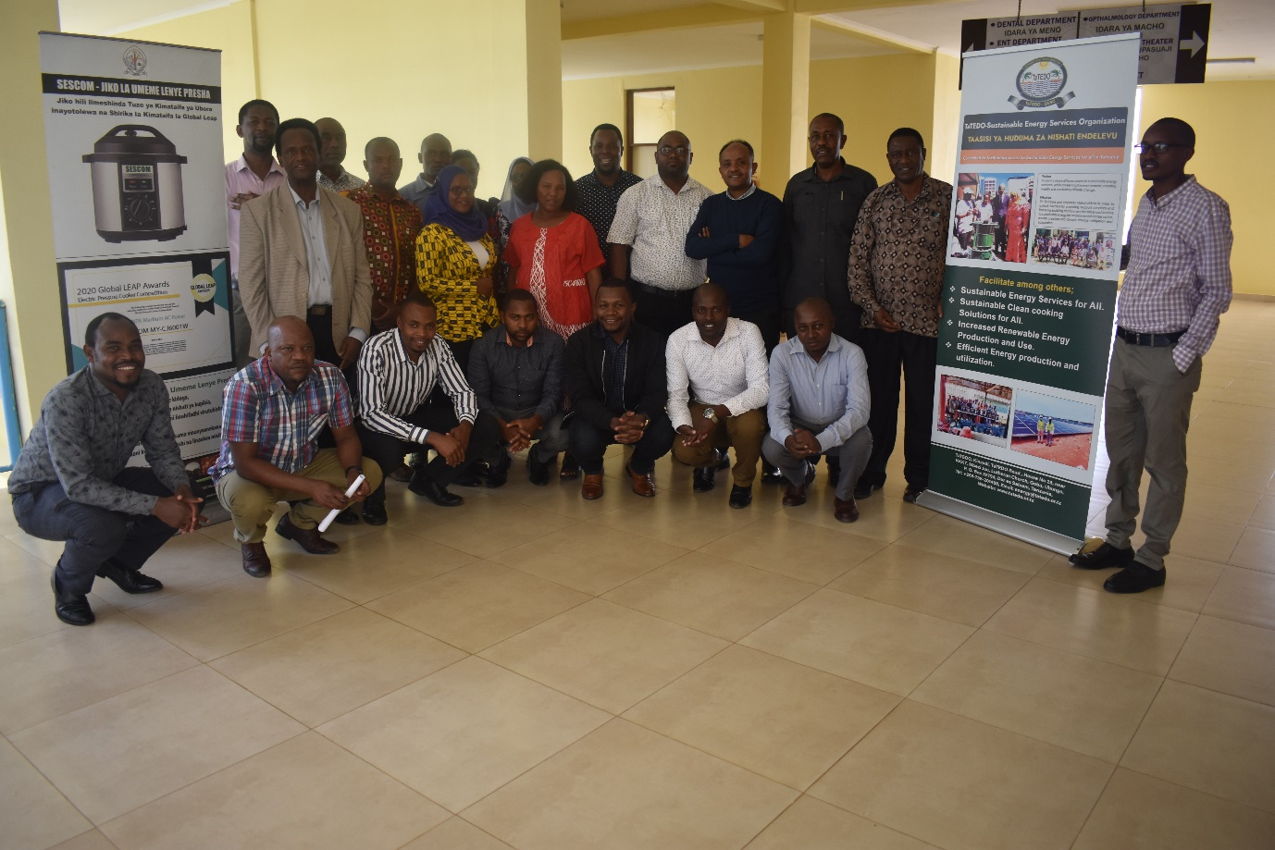
Training Participants at Uhuru Hospital Conference Hall

Report of the Training on Energy Access Explorer and Local Level Energy Planning Handbook
Chamwino District Council, Dodoma

21-22 November 2022

Table of Contents

Table of Contents ii
Abbreviations iii
1.0 INTRODUCTION 1
1.1 Background Information 1
1.2 Participants of the Training 1
1.3 Venue and Date 1
2.0 METHODOLOGY 2
3.0 TRAINING AND ASSOCIATED EVENTS 2
3.1 Opening and Introduction Sessions 2
3.1.1 Opening Remarks by Eng. Estomih Sawe-TaTEDO-SESO CEO 3
3.1.2 Opening Remarks by Mr. Sanford Kway from PO-RALG 3
3.2 Experience from the Ministry of Energy by Eng. Shukurani Rugaimukamu 5
3.3 Experience on Energy project and planning from Dodoma City Council by Ally S. Mfinanga 6
3.3 Presentation on Local Level Planning Hand Book by Jensen Shuma from TaTEDO-SESO 7
3.3.1 Conceptual Overview on Energy 7
3.4 Presentation on Energy Access Explorer by Douglas Ronoh (WRI) 12
3.4.1 Concept and Demonstration on Day 1 12
3.4.2 Hands on Exercises and Group Activities 19
Annex 1: Name of Participants of Energy Access Explorer Training, Chamwino 23
Annex 2: Training Programme 24
Annex 3: Energy Access Explorer Tutorial Materials 25

Abbreviations

CEO Chief Executive Officer
EAE Energy Access Explorer
GIS Geographical Information System
Kw Kilowatt
LGA Local Government Authority
M&E Monitoring and Evaluation
MoE Ministry of Energy
MoU Memorandum of Understanding
PO-RALG President Office-Regional Administration and Local Government Authority
PRA Participatory Rural Appraisal
PV Photo Voltaic
REA Rural Energy Agency
SDGs Sustainable Development Goals
SEA4ALL Sustainable Energy for All
SMEs Small and Medium Enterprises
TANESCO Tanzania Electric Supply Company
TaTEDO-SESO TaTEDO -Sustainable Energy Services Organization
UN United Nations
UNIDO United Nation Industrial Development
VPO Vice President Office
WB World Bank
WRI World Resources Institute

1.0 INTRODUCTION

1.1 Background Information
TaTEDO-SESO and WRI organized a capacity building training to District Planners from Kongwa and Chamwino District councils (DCs). The training was organized as a way to contribute addressing the local level energy planning gaps which has been an obvious major challenge to the government day to day activities at the local or subnational level. In Tanzania, like in many other countries in Africa, energy in particular biomass and rural energy planning and development at the local level has received relatively little attention, compared to planning for other energy sources (grid electricity and petroleum products), although biomass energy accounts for about 85% of the country’s energy supply.
As a result, there is less understanding of the complexity and diversity of energy systems at the local levels. There is also inadequacy of reliable data and information on energy resources, their consumption and interaction with social, economic, cultural, institutional, and environmental factors. This is largely due to a lack of adequately developed and easily understood methods of gathering energy data and information, related analysis, and tools and processes for evaluating available energy options for significant impacts.
On those grounds, the organized training to district planners has helped them to realize and become aware on how they can be able to identify, assess, and understand locally available energy sources and integrate them into their plans so that can contribute to satisfying the energy and priority needs of the rural households, agricultural and small-scale industrial sectors, promote growth and facilitate sustainable development in particular communities/ districts.

1.2 Participants of the Training
The training participants came from Kongwa and Chamwino District councils, the Ministry of Energy, the president office, and Dodoma City Council. The list of all the participants is attached as Annex 1.

1.3 Venue and Date
The training was conducted on 21st -22nd November 2022 at the conference room at Uhuru Hospital, Chamwino District Dodoma, Tanzania

2.0 METHODOLOGY
During this training, the main focus was to enlighten planners from the District Councils on how best the energy activities can be organized, planned and integrated into district plans through GIS Based tools and local level energy planning handbook.
The training was conducted for two days whereby on that course a training program/ time table to guide the sessions was developed as seen at Annex 2.
The program started at 9:30am and ended at 17:00hrs for the first day and in the second day the session started at 9:00am and ended at 16:00hrs. The timetable had two main parts where in the first day it started with the opening and welcoming remarks from the host and the training organizers and continued with brief narrations on experience on importance of energy and its planning from the represented ministries and Dodoma City authority, presentations on the main focus area of local level energy planning handbook and energy access explorer. The second day of the training was more on the practical whereby participants had time to do their individual and group works on energy access explorer; to determine and practice on various factors which are key when planning for energy interventions. In this section, they were able to understand the Energy Access Explorer, how it functions, and be able to undertake analysis on the assignments they were provided in group work.

3.0 TRAINING AND ASSOCIATED EVENTS

3.1 Opening and Introduction Sessions
The moderator of the day one morning sessions of the training was Mr. Shukuru Meena who started by welcoming and thanking all the participants for honoring the invitations. He gave a brief introduction on the purpose of trainees gathering at Chamwino, the objectives and what were the expectations for the two days. He also extended the gratitude to Chamwino District Council for providing the training venue and also for their cooperation which led into successful implementation of the project “ Linking Energy and Development: A User-Centric Approach-in Tanzania”. He also took the participants through the training program and later the participants did a self-introduction.
Thereafter, Mr. Shukuru invited Mr. Godfrey Mnyamale, the Chamwino District Agriculture and Irrigation Officer, for a few welcoming remarks. Mr. Mnyamale started by thanking both TaTEDO-SESO and WRI for organizing the training and for supporting the Huzi Mango farm project whereby a 12Kw Solar PV system was installed to power water pump and drip irrigation system installed as pilot for 25 acres of Mango farm. He narrated how important and timely the support was to the farmers after a long-time challenge in operating the diesel-powered plant which was too costly for farmers to afford. For the training he said that through different session that they have had with TaTEDO-SESO during implementation of the project, they have realized that there is a gap in integrating energy related issues in the district plans, so he thought that the two days sessions would be useful and a good start in their planning. He also argued other colleagues from Kongwa and Chamwino District council to be attentive so that whatever they learn they will be able to train other colleagues in their offices who had no chance to attend the training.

3.1.1 Opening Remarks by Eng. Estomih Sawe-TaTEDO-SESO CEO
Mr. Mnyamale later welcomed Eng. Estomih Sawe, TaTEDO-SESO CEO for few remarks. Eng. Sawe started by thanking Chamwino and Kongwa Districts for their long-time continued cooperation and support on various activities that they have been engaged/ involved.
He started by saying there is a huge gap in planning issues at district level because there are no officials with energy knowledge. He said that a lot of project activities take place at district level but since there is no significant knowledge on energy issues a lot of things are overlooked. He gave an example when social services infrastructures such as schools and hospitals are built, there is little consideration on the energy infrastructures to the buildings, or even clean cooking energies.
He urged participants to be cooperative so that at the end of the two days trainings they will be equipped with a knowledge that will help their districts and the national at large to have integrated plans that will bring true changes at ground level.
He also said that despite the SE4ALL and the Government targets of year 2030 that 75% of Tanzanians to have access to clean energy solutions, the targets cannot be attained by the Ministry of Energy (MoE) to work itself, rather district councils should also be part of the efforts from the grass roots, they should be capacitated as to be able to plan, implement, monitor, evaluate and ensure people get access to renewable energy, clean energy solutions for lighting, cooking and for productive uses and leave behind harmful energy sources which are not environmentally friendly.
He explained that now the technology for planning has advanced and in the training sessions experts would take the participants through different sessions including looking at the draft energy planning handbook and the web-based online open source and interactive geospatial platform for learning and discussions.
He thanked the participant and asked them to be attentive so that the objectives of having the sessions at Chamwino become productive.

3.1.2 Opening Remarks by Mr. Sanford Kway from PO-RALG
After Eng. Sawe remarks, the moderator of the morning sessions welcomed Mr. Stanford Kway from PO-RALG for the key note address and opening remarks. Mr. Kway started by narrating that the PO-RALG Ministry is among the largest ministries and it has 13 departments and among the issues they coordinate and supervise includes economy, productivity and energy issues. He said that with the president instrument, the PO-RALG has mandate to coordinate all sectorial ministries on their implementations at regional and district level.
He also said, the ministries have their own mandate to develop policies, strategies, regulations, Acts but when it comes to implementation, it is PO-RALG mandate to ensure what has been planned is achieved at all levels.
Mr. Kway also narrated on the decentralization approaches that the government imposed and how it has been implemented. He said that previously the sectoral ministries were allowed to give directives and guidance to the implementers at ground/ local levels. The approach was not so much effective as was so many directives which in one way or another led into ineffectiveness to the services delivery to the people and it was difficult to hold a particular ministry or officer accountable. So, the Ministry PO-RALG through the President instrument coordinates other ministries activities at improved efficiency.
Kway said that the challenges the PO-RALG face at energy sector is that it is not decentralized to local level as other sectors such as Health and Education. So due to that challenge, PO-RALG has role to ensure energy sectors is well implemented and it is the wish and it is the government plans to ensure in the future, the energy desk will be established and integrated into Local Government structures. He added that there are many opportunities if the sector is decentralized whereby during planning, it is possible to include energy plan in the strategic plans of districts. He said that a one- or two-day training may not be enough to make the required and significant changes rather there should be a long-term strategy to capacitate and ensure every district is aware and start to integrate energy in their plans.
Mr. Kway also said that the term energy is still perceived by many as electricity for lighting, but he said it is a broader term which by his knowledge it also includes energy for cooking, productive uses. He argued for collaborative efforts which will make sure people uses energy efficiently, but also for productive uses to improve their livelihoods.
As a way of showing commitment, Kway said that the Government is willing to work with private sectors and development partners such as TaTEDO-SESO/ WRI, UNIDO, UN,WB to continue ensuring the electrification projects, awareness creation, business and micro-entrepreneurship trainings are extended to the last mile customers who have been marginalized and lack access of energy that can help them realize the social economic potentials at their surroundings.
Mr. Kway said that the PO-RALG is aware of what TaTEDO-SESO and her partner WRI are doing on the ground level that is why whenever there are new initiatives they always support by giving a proper introduction of TaTEDO/WRI to stakeholders at regional and districts. He said the training has only been conducted to the two district councils but there is more than 184 district councils, which in his views needs similar capacity building. So, in near future PO-RALG shall have in-depth discussions to see how the rest of the districts can benefit from the knowledge within TaTEDO-SESO/ WRI.
Kway urged participants to go through the Local Level Planning Handbook, to give inputs so that once finalized it can be used in the whole country as inputs from local level will already be incorporated. Mr. Kway said due to the gap in planning, he wishes one day the Local Planning Handbook being launched and recognized as an official energy planning guide handbook in the country.
At the end, he announced the Training to be officially opened and requested all the participants to be keen and take issues which they think can bring immediate impacts in terms of planning to their respective district while waiting for the handbook to be finalized and launched as planning tool at local levels.

3.2 Experience from the Ministry of Energy by Eng. Shukurani Rugaimukamu
The overall overview on energy situation and experience on planning and implementation of different national energy interventions was briefly presented by Eng. Shukurani Rugaimukamu, the energy engineer from the Ministry of Energy. He briefly elaborated on the Ministry Operation structure, how the Ministry operates to ensure Tanzanian get access to sustainable energy for their livelihood improvements. Among the departments he narrated were Petroleum and Gas and which is dealing with exploration of gas (different local and overseas companies are involved)while Electricity and Renewable Energy Department deals with generation, transmission, distribution and utilization of electricity through different agencies and companies managed by the Government.
On the electricity distribution, the Government through Rural Energy Agency (REA) electrification programs has reached more than 9,000 villages and the plan is to electrify all villages in Tanzania mainland by year 2025.
He also explained how the Ministry of energy has been working with different stakeholders including private sector such as TaTEDO-SESO and WRI and the impacts of their collaboration has been witnessed in different regions and districts in the country. He reminded the participants that on 1-2nd November 2022 the Ministry organized a national clean cooking conference which involved a number of stakeholders within and outside the country who deals with clean cooking. On that conference a number of presentations were made and he hailed TaTEDO and other stakeholders by presenting well their experience on the potential of clean cooking solutions, how can they be made accessible, mechanisms to make clean cooking energy affordable and even some employments which can be created through the clean cooking solutions. He insisted on the impacts of non-clean cooking energy which are degrading the environment and healthy of users where he pointed that more than 32,000 end users die every year.
On the importance of the training at Chamwino, Eng. Rugaimukamu said that the training has come at the right time whereby though he is coming from the Ministry of Energy, the ministry staff still need to learn and acquire more knowledge which is shared by other stakeholders. He said that other initiatives which are useful in planning are also welcomed by the Ministry so as to accelerate achieving the SE4ALL targets by year 2030 to have 75% of the population accessing clean energy. His lastly insisted that the targets can’t be achieved by Government itself rather through joint and collaborative efforts from all the stakeholders, hence congratulating TaTEDO-SESO and WRI for organizing and inviting government departments as well.

3.3 Experience on Energy project and planning from Dodoma City Council by Ally S. Mfinanga
The experience of how the energy issues and projects/ programs are planned and implemented at Sub-national Level was presented by Mr. Ally S. Mfinanga, Dodoma City Council Environmental Officer.
He started by narrating the potential energy sources in Dodoma and the surrounding areas which included wind and solar energy. He said that since Dodoma city is growing fast and it is a semi-arid area, the Dodoma city council has initiated some electrification programs. The program is implemented in collaboration with TANESCO and the Embassy of Finland whereby a wind turbine has been installed at Nala Village. There are still some processes to reach the Power Purchasing Agreement and once the parties agreed, the generated electricity will be sold to the national grid.
Other initiatives by the Dodoma City council has been to invite other stakeholders to invest in energy and he said one company “ he forgot the name” has shown interest to invest in solar power plant and initial discussions have started.
On other hands, it was presented that many households in the city and the villagers around are using solar PV systems for lightings, powering radio and other appliances. This is reducing the use of diesel, and other non-environmentally friendly sources such as kerosene and firewood. Another initiative by the city is that they are in discussion with American Company which has joint venture with Zimbabwe based company to generate electricity using solid wastes from the city. The MoU with these investors will be signed on January 2023 and once implemented it is expected to increase the electricity access in the city.
Mr. Mfinanga also said that Dodoma has a number of small SMEs who produce a lot of feedstock from rice husk, maize cobs, groundnuts husk, sawdust and these when processed can be used as source of energy to generate electricity or used as briquetted for cooking in institutions or at household level to reduce environmental degradation. He insisted that in recent years the Vice President Office (VPO) instructed that all institutions which serve more than 200 people has to stop using firewood and charcoal and switch to alternatives such as briquettes, gas or electricity.
He insisted that their mandate as Dodoma City council is to ensure those instructions from VPO are implemented by the particular institutions as to ensure the environment is conserved and people are getting energy services as required. He also welcomed TaTEDO-SESO for any new program in Dodoma but appreciated the ongoing efforts and projects in the city such as awareness on the use of electricity for cooking and capacity building to technicians on repair and maintenance of electric pressure cookers.

3.3 Presentation on Local Level Planning Hand Book by Jensen Shuma from TaTEDO-SESO

3.3.1 Conceptual Overview on Energy
Mr. Shuma started the presentation by giving the general overview of the energy; the following were key areas of presentation;
- What is the importance of Energy Planning?
- Energy is an essential requirement for human welfare development which is required for lights, cooking, industries, business services, faith, mining, etc.
- The local levels of Tanzania are facing problems of lack of energy planning due to lack of local level energy institutional structure which results into inadequate energy services and infrastructure for providing energy services
- The lack of adequate energy services at local levels has social dimensions as well as serious environmental and health effects.

- Institutional Framework and Market Structure for the Energy Sector
During the training, the institutional framework of the energy sector in the country, the key stakeholders and their roles in the sector were presented to the participants as seen in the structure below.
MINISTRY OF ENERGY
ENERGY AND WATER REGULATORY AUTHORITY
RURAL ENERGY AGENCY
TANESCO
Imports
Independent Power Producers
Co-funding, capacity building,
pre-investment support
Stand-Alone System Service Providers
Small Power Producers / Mini-Grid Service Providers
Stand-Alone System Customers
TANESCO Distribution
Retailed Grid and Mini-Grid Customers
REGULATIONS
ENFORCEMENT
SPPA, PPAS & BULK TARIFF APPROVAL, LICENSING
RETAIL TARIFF
APPROVAL
CUSTOMER COMPLAINS

- Aim of the Local Level Energy Planning Handbook
- The draft handbook was presented to the participants. It was informed that the aim of the handbook is to guide different stakeholders including local government authorities, NGOs, private sectors, and communities involved with local area- specific energy planning and development.

- Why do we Need Local Level Energy Planning?
- Energy in particular biomass and rural energy planning and development at the local level has received relatively little attention, compared to planning for other energy sources
- Inadequacy of reliable data and information on energy resources, their consumption and interaction with social, economic, cultural, institutional, and environmental factors.
- Lack of sustainability for interventions at the local levels
- Planning for energy access at the local level is not commonly practiced in government institutions and local organizations are unfamiliar with the planning concepts and best practices,
- Ongoing transformation in energy markets is allowing stakeholders for new options of using and producing energy.
- Need for local governments in Tanzania to explore opportunities in the energy sector and generate their energy by establishing and investing in energy projects.
- The effects of climate change which are making it even more urgent to plan for the resilience of communities, including energy interventions for mitigating or adapting climate change to improve their livelihoods and bring economic development.

- What to Consider during Developing Local Level Energy Plans
In developing local level energy plans, four important issues need to be taken into consideration: -
- Public support and participation must be solicited. This will ensure the acceptability and success of technologies introduced.
- Surveys must be undertaken to assess the current energy use situation, identify local needs, and assess local resources.
- Planning must be based on the local identification of needs and local resources. This will help to ensure that the introduction of energy technologies serve the development needs of the local population directly.
- The number of options available (on the basis of local needs and resources) must be narrowed down to only those options that will optimize the development and use of energy sources.
- Planners must think simple and introduce technologies that are socially, economically, and environmentally acceptable by using criteria for ranking energy solutions.

- Who should be Involved in Local Level Energy Planning?
- Energy service delivery usually requires the participation of many different stakeholders who each have their own entry point(s) and criteria for participation.
- The first step in the process is to identify, prioritize and engage with relevant stakeholders, especially organizations or individuals that will be of value in planning the future energy systems and their delivery.
- Stake holders’ engagement and a participatory approach to stakeholders mapping should be used to find out different drivers and interests of different actors, to identify the potential roles each stakeholder can play, and to develop a shared understanding of the end users’ needs and wants.
- The stakeholders should be selected depending on levels of energy planning at local levels (regions, districts, ward and village levels)

- Tools for Local Level Energy Planning
- Energy Access Explorer (EAE)
- Energy Access Explorer is an online, open-source, interactive, geospatial platform that uses mapping to visualize the state of energy access in unserved and underserved areas.

- Participatory Rural Appraisal (PRA)
- PRA is a combination of approaches and methods for sharing, analysing people lives, development and conditions, in order to plan and act. The methods involved include mapping and modelling; transect walks, matrix scoring, seasonal calendars, well-being and wealth ranking and grouping, and analytical diagramming.

- Delivery Model for Modern Energy Services
- This is planning which combines the technology, finance, management activities, business, marketing, enabling environment, legal arrangements and relationship types required to supply modern energy services to a group of people or end users.

- Local Level Energy Planning Steps
Different steps towards the local level energy planning were explained to the training participants. The steps were;
- Assessment of the current energy situation,
- Define the target group for the intervention and its geographical and socio-cultural context, gathering the initial baseline information includes literature review for secondary data, primary data collection,

Information required will include:
- Basic geographical information about the village, ward and district
- Basic socio-economic conditions in the community
- Economic activities including agricultural production systems
- Social structures (leadership structures and customs), level of social cohesion
- Presence of external stakeholders in the community
- Existing energy infrastructure
- Existing or planned larger public or private led economic ventures or development initiatives.

- Assessment of energy market
Demand: In order to determine energy service needs, it is necessary to take a closer look at how the energy is to be used and in what technical and socio-economic conditions it is required by.
- Identify and assess priority energy needs and wants
- Balancing shorter and longer term wants and needs is important in meeting demand for energy services
- Both the identified priority energy needs and wants can then also be presented visually in a map.
- Market system assessment focuses on understanding market and context analysis, by analysing which value chain combinations would be required for energy delivery to the end users.
- This will involve detailed assessment of the key aspects of market system (i.e. market chains, support services and enabling environment) and identification of potential target segments.
- There is a need to assess enablers, constraints and drivers of the marketing the energy products in the market
- Energy Market Chain Assessment
- Designing Modern Energy Delivery Model

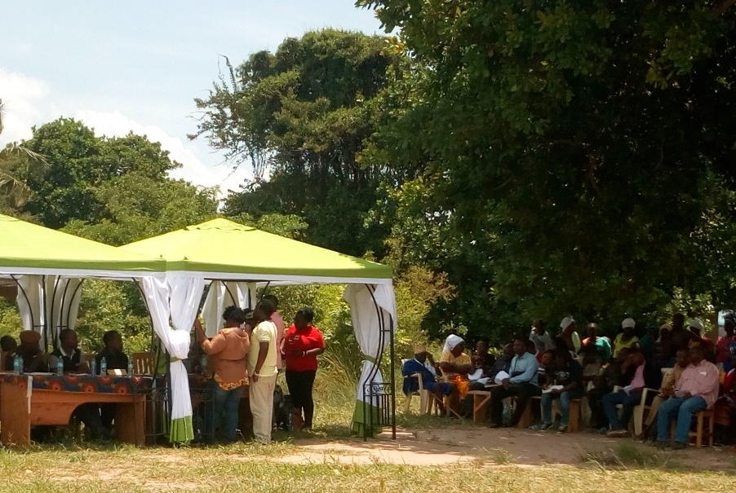
- Preparation of Implementation Plan for the Identified Energy Solutions
This step involves developing a detailed implementation plan with specific timelines, inputs, deliverables, roles, and responsibilities assigned to each stakeholder.

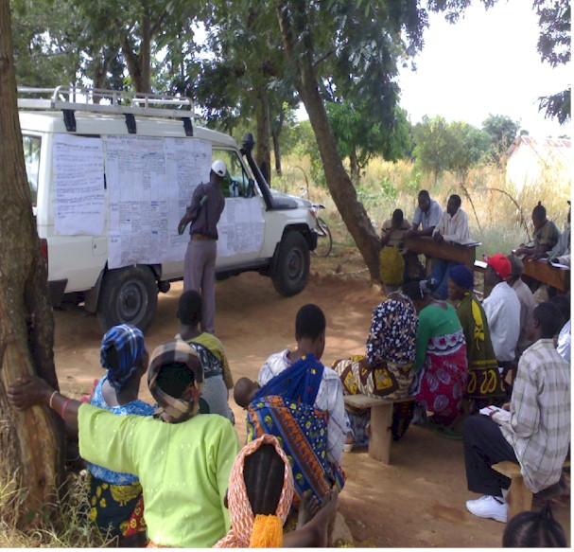
- Resource Mobilization
Resource mobilization strategy will ensure financial and other resources are available at national to local levels for implementation of planned activities of providing energy services at local levels.

- Implementation
This is the key step whereby;
- Changing the energy plans agreed with stakeholders into actions
- The implementation requires to work closely with people at local levels in order to ensure what is implemented adhere to their needs
- Implementation of all activities as they appear in the plan milestones to be implemented properly
- Proper implementation of plans requires strict adherence to the time (period) allocated to action
- There must be team of people backing up the implementation at different hierarchies of administrative structure e.g. village or ward energy team, district energy clusters (if the local government is missing local level institutional structure)

- Monitoring and evaluation
- This is the step which ensures the agreed action plans are well implemented at the agreeable timelines. The Final M&E strategy should integrate the findings from the pilot and monitor implementation of both the delivery infrastructure and the overall energy service once it is operating with regular reviews–checking maintenance, financing etc.
- M&E methods should also assess the community’s level of economic development attributable to having greater energy access.

Conclusions
- The Local Level Energy Planning Handbook (LLEPH) have tools which can move energy services at local levels to another levels (up the energy ladder).
- What is required from the government and local governments is the structure which will support use and implementation of contents of this handbook.
- The structure can either be the establishment of energy desk at district level or the formation of district energy cluster from existing departments
- However, energy planning and implementation should tailor in such a way that will generate income to the district councils

3.4 Presentation on Energy Access Explorer by Douglas Ronoh (WRI)
The training on the energy Access Explorer was divided into two main parts; the first part was on the Introduction of the concept and demonstration, and this was done on the first day and the second part was on the hands-on exercises and Group Activities, which was conducted on the second day of the training.

3.4.1 Concept and Demonstration on Day 1
What is Energy Access Explorer?
Energy Access Explorer (EAE) is an online, open-source, interactive, geospatial platform that enables clean energy entrepreneurs, energy planners, donors, and development-oriented institutions to identify high priority areas where energy access can be expanded. Using spatial data to link energy supply with growing or unmet demand is essential to gaining a better picture of energy access and expanding energy services to those who need it the most.

EAE synthesizes several geospatial data to visualize and analyse demand for energy services. Examples are Demographics such as
population density
- poverty rates
- asset ownership etc
Social and productive uses, including:
- Schools and Health clinics
- Agricultural activities,

Similarly, EAE incorporates data to represent current or potential energy supply. These include: Resource availability, including
- wind power
- solar power
- small-scale hydropower, etc

Power infrastructure, including:
- transmission network
- distribution network
- generation network
- mini grids

Furthermore, it incorporates important data on:
- environment (such as protected areas and forest cover)
- access to finance (such as finance service providers)
- and other categories (such as refugee settlements).

Energy Access Explorer enables all users to make multi-criteria decision analysis on-the-fly and identify high-priority areas where access to energy should be expanded. Beyond its visualization and analytical capabilities, EAE functions as a dynamic geographic information system and data repository which reduces software engineering and data transaction costs for both data providers and users. Its unique backend infrastructure comes with an easy to navigate Content Management System and allows administrative users with limited or no GIS and programming expertise to add data and metadata in a simple manner
Energy Access and Sustainable Development Outcomes
Access to Sustainable energy promote development and improve the livelihoods of the populations through improved access to social services and economic activities. In the course of use in different sectors, energy is interconnected with 125 (74%) out of 169 SDG targets.

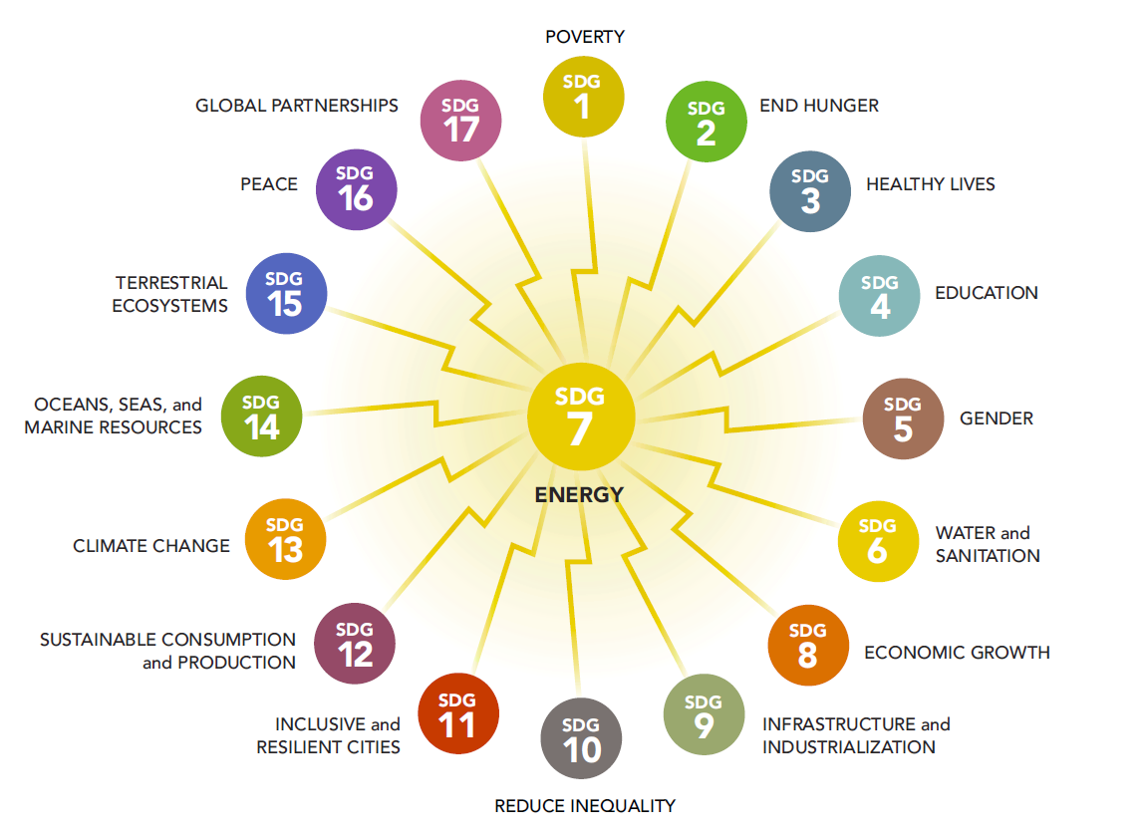

What is the Importance of Integrated Energy Planning?
Planning is essential for several things among them include;
- matching supply with the growing demand
- incorporating decentralized and cost-effective renewable energy production into a region’s energy mix.

Ecosystem of Online Geospatial Energy Access Tools
Different functions that the tools can do were presented, these included;
- Mapping Renewable Energy Potential
- It is eessential for assessing the potential penetration of RE technologies
- With llimited or no information on demand

- Identifying Markets for Off-grid Electrification
- Potential markets for off grid technology
- Limited data on social and productive uses
- Limited GIS functions
- Often proprietary software
- Limited stakeholder engagement and ownership
- Remain outdated.

- Least-cost Electrification Planning
- Least cost electrification technology and investment outlooks
- Pre-run scenarios due to heavy computational requirements
- Limited data on demand
- Analysis on the fly limited to filters
- Limited or no national ownership

- Reduce Reliance on GIS and Programming Expertise for Data Users

What are the steps towards Customizing Energy Access Explorer in Tanzania?
During training, the participants were introduced on the best approaches that can lead into an inclusive energy access explorer. Below are the key steps

- Stakeholders Engagement
This is the bottom up approach which ensures all stakeholders are from local to national level are involved.

- Coordination and Collaboration
A close collaboration among the stakeholders in key to the success of Energy Access Explorer. Each one at respective capacities has roles that collectively makes the EAE operational.

- Data Collection and Analysis

What is the Sustainability Plan for the Energy Access Explorer Platform?
Short Term | Long term
User Training workshops | Minimum of 5years technical support
Training Materials | Benefit from technical advancements deployed in other geographies
Share admin rights with key administrators | Participate in EAE Steering Committee
Automate data processes | Participate in EAE Steering Committee

ENERGY ACCESS EXPLORER TOOL DEMONSTRATION
Since the EAE tools were not familiar to the trainees, a demonstration on the Front-End Explorer, associated tools, was carried out. This was the first stage where participants were showed and guided on various datasets, how to filter some of datasets, how to analyses the data and many more. Each participant had time to browse individually for more familiarity to the tools. Below are some of the presentation slides showing the demonstrations on different overviews
Slide 1: General Data Features and Menu

Slide 2: Demand Data set details

Slide 3: View of Analyzed Data

3.4.2 Hands on Exercises and Group Activities
The second day of the training began by participants to have time to reflect on what they learnt on the previous day. During reflections the main questions emerged were on the access to the explorer especially when it needs to be updated. The trainer explained in details that in the future a workgroup that will consist experts from different institutions will be established and they will be able to access the platform to update the information.
Thereafter the trainer provided the tutorial materials to trainees for individual exercises and group works activities. In the undertaing the assignements, the trainees used the tutorial as a guide. Please refers to Annex 3.
- Individual Exercises
- Census data. Locate the following data for Tanzania
- Assets: Radio ownership % in Chamwino district
- Lighting: Electricity % in Kongwa district
- Assets: Mobile phone ownership % in Kongwa district
- Assets: Roof permanent ownership % in Chamwino district

- Add the following layers and identify
The trainees had to follow the tutorial to be able to add the layers and identifiy specific locations as per the guidance as seen in the table below;
Layer | Identify
Population density | Locate areas with the highest population densities
Population density | Locate the city of Dodoma in the Dodoma region
Population density | Locate other major urban centers within the Dodoma region
Schools | Locate Schools in the Dodoma region  Indicate the different attributes available per schools
Satellite base map and Global Horizontal Irradiation (use transparency feature to visualize base map and GHI layer) | What is the solar irradiance range (max-min) found in Dodomaregion?
 | What is the solar irradiance in Gulwe?
Hydropower potential -small scale | Provide a summary of small-scale hydropower available in Dodoma region. Identify one point for small-scale hydropower potential in Dodoma.
Hydropower potential -small scale | What is the potential hydropower?

- Analysis
After succesfully passing stage 2, the trainee were supposed to analyse the data by also adding some datasets such as population density, distribution lines and locate areas in Chamwino district that are not within range of the grid and estimate the total population(nationally) that is far from the grid.
- Present the findings
The trainer was passing through each participants desk to examine and support on the exercises and through the tutorial majority of trainees managed to complete their assignment.

- Group Activities 1-Analysis
The trainees were then divided into 3 groups and each group was given an assignement. This was analysis based on the instructions given in the tutorial. For group activity 1, the analysis Question were as per table below;
Analysis-1

Task | Analysis Questions
Add Population density and a productive/social use of your choice (Schools, Healthcare facility, Mines or Crops). | In the Analysis view of the EAE. Are there any areas that appear with a high energy access potential (lightest color)? Choose one of these areas and explain why this could be high.
 | Estimate the total population near this service.
 | Locate the areas of your productive/social use not within range of the grid

Analysis -2
Task | Analysis questions
Add Population density and GHI. Locate areas with high global horizontal solar irradiance. | What is the total area in Tanzania with high solar irradiation? (Above 2,000 kWh/m2)
 | What is the total population in Tanzania within this area of high solar irradiation? (Above 2,000 kWh/m2)
What is the solar irradiance potential for your chosen productive/social use data in these areas?
    - Majimoto
    - EngareSero
    - Ugalla

Analysis-3
Task | Analysis questions
Add population density & night-time lights and locate | Population with low night-time calibrated radiance . What is the population? (radiance < 2)
Add population density & night-time lights and locate | Area share of this population
Add distribution lines | What is the population distant from the grid within this low nighttime radiance? (Distribution lines > 2km)
Add distribution lines | What is the population in proximity to the grid? (Distribution lines < 2km)

- Group Activities 2-Case Scenarios
Another set of group activity was given to participants, whereby they were required to analyze different scenarios and present their findings to the rest of the class. The Questions for each scenario were as follows;
Scenario 1 -Strategic energy planning
Question for scenario 1: Suppose you are an analyst at the Ministry of Energy and would like to indicate high priority areas where access to energy could be expanded by extending the grid network or possibly setting up off grid options.
Create a multicriteria analysis combining at least 5 datasets from demand, supply and other to indicate high priority areas where the grid should be expanded.
Scenario 2 -Expansion of clean energy markets
Question for Scenario 2: Suppose you are a solar home system developer searching to expand clean energy markets by identifying where potential customers may be located and validating collected data.
Create a multicriteria analysis combining at least 5 datasets from demand, supply and other to indicate high priority areas where the markets should be expanded.

Scenario 3 -Donors and development finance institutions
Question for Scenario 3: Suppose you are an analyst in a development finance institution interested in identifying areas where assistance is most needed & investment could have a greater impact.

Create a multicriteria analysis combining at least 5 datasets from demand, supply and other to indicate high priority areas where investments could have the greatest impact.

Scenario 4 -Service delivery institutions in the health, education, and agriculture
Question for scenario 4: Suppose you work in a government agency supporting an off-grid electrification program for irrigation in the agriculture sector. You are interested in identifying areas with potential energy needs associated to crop irrigation.
Create a multicriteria analysis combining at least 5 datasets from demand, supply and other to indicate high priority areas for this off-grid electrification program.

Scenario 5 -Productive use of energy in mining
Question for scenario 5: Suppose you are head of a mining corporation of Tanzania and are planning to develop processing factories in Dodoma region.
Task: Create a multi-criteria analysis combining datasets from electricity/energy supply, mining sites, protected areas to indicate high priority areas where the processing plants can be located.

- Presentations of the findings
The scenarios working groups ending up with representative from each group present their findings based on the provided questions. Though there was no enough time to prepare the presentations in the power points, the presented information was assessed by the trainer and declared that the trainees had done a good job.

- Proposed Actions
After the two days training sessions, a number of several issues were agreed as next steps towards having a final version of the Local level energy planning handbook and making sure it become a useful planning tool at the District Level. Among them includes;
- The trainees from respective districts to read carefully the draft Handbook document and provide their inputs for finalization of the book.
- Trainees to keep on practicing and become familiar with both the Energy Access Explorer tool, as a way to start improve their ways of working and planning.
- TaTEDO-SESO and WRI to incorporates the inputs from different stakeholders and print few copies that will be presented to PO-RALG and other key relevant ministries as starting point towards adoption as official planning tool.
- Once accepted by the Government authorities, TaTEDO-SESO and WRI develop similar initiatives so that many more other district councils’ planners and key departments officials can be trained to ensure energy issues are mainstreamed in the local level government plans.

- Closing Session
As a closure of the two days training, the trainer Mr. Douglas Ronoh invited the participants to give any feedback regarding what they have learnt for two days. Some said that the training was good and learnt a lot of good stuff, but the time was too short to grasp all the concepts but they will keep on practicing. They also wanted to know how they will give their feedback and whether it is possible to update and incorporate new information in the explorer.
Thereafter, Mr. Jensen Shuma from TaTEDO-SESO, had time to briefly give a wrap-up remarks and urged all participants to continue practicing on EAE, give their feedbacks and inputs on the local level handbook so as to speed up printing process. He also gave a word of thank to WRI, Douglas Ronoh, the Chamwino District Council for hosting the training and all who in one way or another contributed into successfully undertaken training.

Annex 1: Name of Participants of Energy Access Explorer Training, Chamwino
S/N | Name | Organization | Designation | Telephone | Email Address
1 | Adugna Nemera | WRI-Africa | Senior Finance Associate | +251 91 148 5305 | adugna.nemera@wri.org
2 | Alfonce Onesmo Mkwizu | Kongwa DC | Deputy District Community Development Officer | 0629 258746 | alphoncemkwizu@gmail.com
3 | Ally S. Mfinanga | Dodoma City Council | City Environmental Officer | 0713 339 769 | amfinanga@hotmail.com
4 | Benson Ireri | WRI-Africa | Africa-Lead | +254 738 784488 | benson.ireri@wri.org
5 | Christine Odeph | WRI-Africa | Communication Officer | +254 746 157 136 | christine.odeph@wri.org
6 | Douglas Ronoh | WRI-Africa | GIS Associate-EAE | +254 714 773494 | douglas.ronoh@wri.org
7 | Ernest James Lumeya | Kongwa DC | District Health Secretary | 0655 763876 | ernestlumeya@gmail.com
8 | Estomih Sawe | TaTEDO-SESO | Chief Executive Officer | 0754 279868 | ceo@tatedo.or.tz
9 | Godfrey Bukoli Mujairi | Kongwa DC | District Environment Officer | 0756 520768 | mujairi@gmail.com
10 | Godfrey Mnyamale | Chamwino DC | District Agricultural Officer | 0713 765 953 | gmnyamale@yahoo.com
11 | Heron Beneth Mahungo | Kongwa DC | Deputy District Primary Education Officer | 0754 456941 | maungoh@gmail.com
12 | James Kuwayawaya | Chamwino DC | District Aids Control Coordinator | 0717 243143 | jameskuwayawaya@gmail.com
13 | Jensen Shuma | TaTEDO-SESO | Senior Manager-Resource Mobilisation | 0713 420 882 | jcshuma@yahoo.com
14 | Jeremia P. Ninda | SESCOM | Energy Engineer-Centre Manager | 0718888099 | nindajeremia@gmail.com
15 | Mugeta Mafuri Karwijila | Kongwa DC | District Planning Officer | 0764 470063 | kurwijira@gmail.com
16 | Neema Mirumbe | Chamwino DC | Deputy District Planning Officer | 0786 125 340 | mirumbeneema7@gmail.com
17 | Sanford Kway | PO-RALG | Coordinator Natural Resources, Environment and Climate Change | 0754 290074 | kwaysanford@gmail.com
18 | Shukuru Rugaimukamu | Ministry of Energy | Energy Engineer | 0766473095 | shukurani.rugaimukamu@nishati.go.tz
19 | Shukuru B. Meena | TaTEDO-SESO | Sustainable Energy Manager | 0765 003 094 | shukurumeena@gmail.com
20 | Valency Sixbeth Basso | Kongwa DC | District Agricultural Officer | 0658 910864 | six.valancy@yahoo.com
21 | Yustina Amo | Chamwino DC | District Natural Resources Officer | 0627 622 285 | justinaamo@gmail.com
22 | Zaina T. Msangi | Chamwino DC | Community Development Officer | 0786 100 492 | msangizaina86@gmail.com
23 | Zena Ibrahimu | Chamwino DC | District Environmental Officer | 0682 857 666 | jirini2003@gmail.com

Annex 2: Training Programme
November 21st
Time | Agenda | Responsible | Facilitator
8:30-9:00 AM | Arrival & Registration | All
9:00-9:10 AM | Opening Remarks | TaTEDO
9:10-9:30 AM | Introductions | All | TaTEDO
9:30-9:45 AM | Keynote Address | PO-RALG
9:45-10:30 AM | - Importance of energy planning  - Energy planning in Tanzania at National & Subnational level (current practices, plans, key stakeholders, etc.,) | TaTEDO | TaTEDO
10:30 - 11:00 | Local Energy Planning work in Dodoma | Dodoma government office
11:00-11:30 AM | Break | All
11:30 - 12:30 AM | Soft launch of the Rural Energy Planning Handbook | TaTEDO | WRI
12:30 - 1:00 PM | Feedback - Q&A - Way Forward for the Planning Handbook | TaTEDO | WRI
1:00-2:00 PM | Lunch Break | WRI
2:00 - 3:30 | EAE Training Day 1 | WRI
 | Introduction of Concepts  - Energy planning and its importance for socio-economic development  - Existing energy planning tools  - GIS data and technology for energy planning  - Ecosystem of geospatial data and tools for strategic energy planning | WRI
 | Introduction to the Energy Access Explorer | WRI
 | Introduction to OnSSET - Least Cost Electrification Model | WRI
 | Energy Access Explorer Tool Demonstration  - EAE tool structure overview  - Data View  - Analysis View  - User scenarios | WRI
3:15-3:30 | Break
3:30-4:00 PM | Day 1 Wrap-up - Preparations for day 2 | WRI
November 22nd
Time | Agenda | Responsible | Facilitator
 | EAE Training Day 2 | WRI
9:00-9:30 AM | Day 1 Refreshed and Day 2 Outline | WRI
9:30-10:45 AM | Individual EAE training exercises | WRI
10:45-11:00 AM | Break | All
11:00-12:00 noon | Group Activity: Analysis exercises | WRI
12:00-1:00 PM | Lunch Break | WRI
1:00-1:30 PM | Group Activity: Scenario exercises | WRI
1:30-2:00 PM | Group presentations | WRI
2:00-2:30 PM | Training Wrap up - Q&A - Feedback - What's next | WRI

Annex 3: Energy Access Explorer Tutorial Materials

